Topic: Project Design and Outline

Tripti Vishwakarma
Colorado State University Global
Course Code: CSC 501-2
Bingdong Li
Aug 11 2024

Project Plan for the Design and Outline of a Software Life Expectancy Model

1. Project Overview
- Project Name: Design and Implementation of a Software Life Expectancy Model
- Project Manager: Tripti Vishwakarma
- Start Date: September 15, 2024
- End Date: January 19, 2025
- Project Sponsor: XYZ Software Solutions
- Budget: $150,000

2. Project Objectives
- Develop a predictive model to estimate the software’s life expectancy.
- Integrate the model with the existing software program.
- Validate the model's accuracy through testing and real-world data.
- Provide comprehensive documentation and training for stakeholders.

3. Scope
- Project Scope:
  - Model Development: Create a predictive model using historical and real-time data.
  - Integration: Embed the model into the current software ecosystem.
  - Testing and Validation: Conduct rigorous testing and validation to ensure accuracy.
  - Documentation and Training: Prepare detailed documentation and provide training sessions for stakeholders.

4. Budget
- Total Budget: $150,000
Category | Estimated Cost
Personnel | $80,000
Software and Tools | $20,000
Training and Documentation | $15,000
Contingency | $10,000
Miscellaneous | $25,000
Total | $150,000
5. Resources
- Personnel:
  - Project Manager: Tripti Vishwakarma
  - Business Analyst: Jane Dwen
  - Data Scientist: John Smith
  - Software Developer: Alice Johnson
  - QA Tester: Bob Brown
  - Technical Writer: Carol White
  - Trainer: Dave Green

- Tools and Technologies:
  - Project Management Software: Jira, Trello
  - Data Analysis Tools: Python, R
  - Development Environment: Visual Studio, Eclipse
  - Version Control System: Git
  - Testing Tools: Selenium, JUnit
  - Documentation Tools: Confluence, MS Word

6. Stakeholder Analysis
- Primary Stakeholders:
  - XYZ Software Solutions: Project sponsor providing overall direction and funding.
  - End Users: Users of the software who will benefit from the life expectancy model.
  - Development Team: Responsible for implementing and integrating the model.
- Secondary Stakeholders:
  - Regulatory Bodies: Ensure compliance with data protection laws.
  - Training Participants: Receive training on the new model and documentation.

7. Project Timeline
Phase | Start Date | End Date | Duration
Project Initiation | Sep 15, 2024 | Sep 21, 2024 | 1 week
Requirements Gathering | Sep 22, 2024 | Oct 5, 2024 | 2 weeks
Design | Oct 6, 2024 | Oct 19, 2024 | 2 weeks
Development | Oct 20, 2024 | Dec 1, 2024 | 6 weeks
Integration | Dec 2, 2024 | Dec 15, 2024 | 2 weeks
Testing & Validation | Dec 16, 2024 | Dec 29, 2024 | 2 weeks
Documentation & Training | Dec 30, 2024 | Jan 12, 2025 | 2 weeks
Project Closure | Jan 13, 2025 | Jan 19, 2025 | 1 week

8. Possible Change Requests and Goal Alignments
- Change Requests:
  - Scope Changes: Adjustments in model complexity or additional features.
  - Budget Adjustments: Reallocation due to unforeseen expenses or additional requirements.
  - Timeline Modifications: Shifts in deadlines due to development or integration challenges.

- Goal Alignments:
  - Review Meetings: Regular meetings with stakeholders to ensure alignment with objectives and manage expectations.
  - Scope Management: Formal change control procedures to address scope changes and align with overall project goals.

9. Project Management Approach
- Methodologies:
  - Agile Methodology: For iterative development and flexibility.
  - Waterfall Methodology: For phases with well-defined requirements.
- Communication Plan:
  - Weekly Status Meetings: With the project team.
  - Bi-weekly Progress Reports: To stakeholders.
  - Monthly Review Meetings: With senior management.
  - Ad-hoc Meetings: For urgent issue resolution.
- Risk Management:
  - Risk Identification: Issues related to requirements, integration, technical challenges, and data availability.
  - Risk Mitigation: Thorough requirements analysis, iterative testing, buffer time allocation, and data validation strategies.
10. Project Closure
- Activities:
  - Finalize Deliverables: Ensure all deliverables meet stakeholder expectations and obtain formal approval.
  - Post-Project Review: Conduct a review to capture lessons learned and areas for improvement.
  - Documentation: Archive all project documentation and materials.
  - Resource Release: Release project resources and formally close the project.

Diagrams and Charts

- Work Breakdown Structure (WBS): Visual representation of project deliverables and tasks.

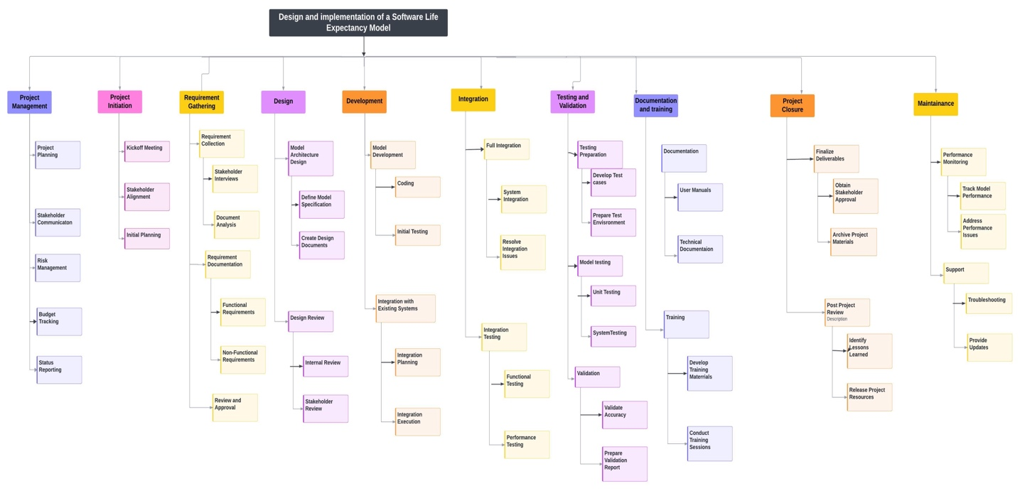

- Gantt Chart: Timeline visualization of project phases and milestones.

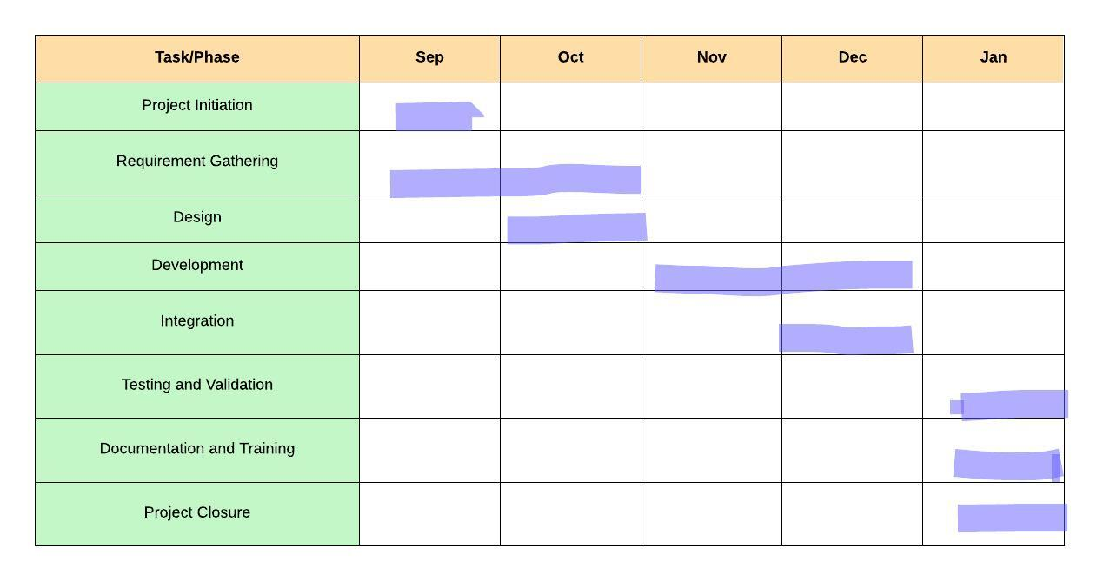

Project Outline

Project Name: Design and Implementation of a Software Life Expectancy Model
Project Manager: Tripti Vishwakarma
Start Date: September 15, 2024
End Date: January 19, 2025
Budget: $150,000

1. Project Scope
Objectives:
- Develop a predictive model to estimate software life expectancy.
- Integrate the model with the existing software systems.
- Validate the model’s accuracy with real-world data.
- Provide comprehensive documentation and training for stakeholders.
Deliverables:
- Predictive Model: Functional model for estimating software life expectancy.
- Integration: Model integrated with existing software systems.
- Validation Report: Documentation of testing and validation results.
- Documentation: Manuals, technical documentation, training materials.
- Training: Training sessions and workshops for stakeholders.
Out of Scope:
- Major software updates beyond integration.
- Long-term support beyond initial training and documentation.

2. Project Timeline
Phase 1: Project Initiation
- Start Date: September 15, 2024
- End Date: September 21, 2024
- Duration: 1 week
- Activities: Kickoff meeting, stakeholder alignment, initial planning.
Phase 2: Requirements Gathering
- Start Date: September 22, 2024
- End Date: October 5, 2024
- Duration: 2 weeks
- Activities: Collect and document requirements, stakeholder interviews.
Phase 3: Design
- Start Date: October 6, 2024
- End Date: October 19, 2024
- Duration: 2 weeks
- Activities: Design model architecture, create design specifications.
Phase 4: Development
- Start Date: October 20, 2024
- End Date: December 1, 2024
- Duration: 6 weeks
- Activities: Develop predictive model, initial integration with systems.
Phase 5: Integration
- Start Date: December 2, 2024
- End Date: December 15, 2024
- Duration: 2 weeks
- Activities: Complete model integration, resolve issues.
Phase 6: Testing & Validation
- Start Date: December 16, 2024
- End Date: December 29, 2024
- Duration: 2 weeks
- Activities: Conduct tests, validate accuracy, prepare report.
Phase 7: Documentation & Training
- Start Date: December 30, 2024
- End Date: January 12, 2025
- Duration: 2 weeks
- Activities: Prepare documentation, conduct training sessions.
Phase 8: Project Closure
- Start Date: January 13, 2025
- End Date: January 19, 2025
- Duration: 1 week
- Activities: Finalize deliverables, obtain approval, conduct review.
Maintenance Phase:
- Start Date: January 20, 2025
- End Date: TBD
- Activities: Monitor performance, provide support, address issues.

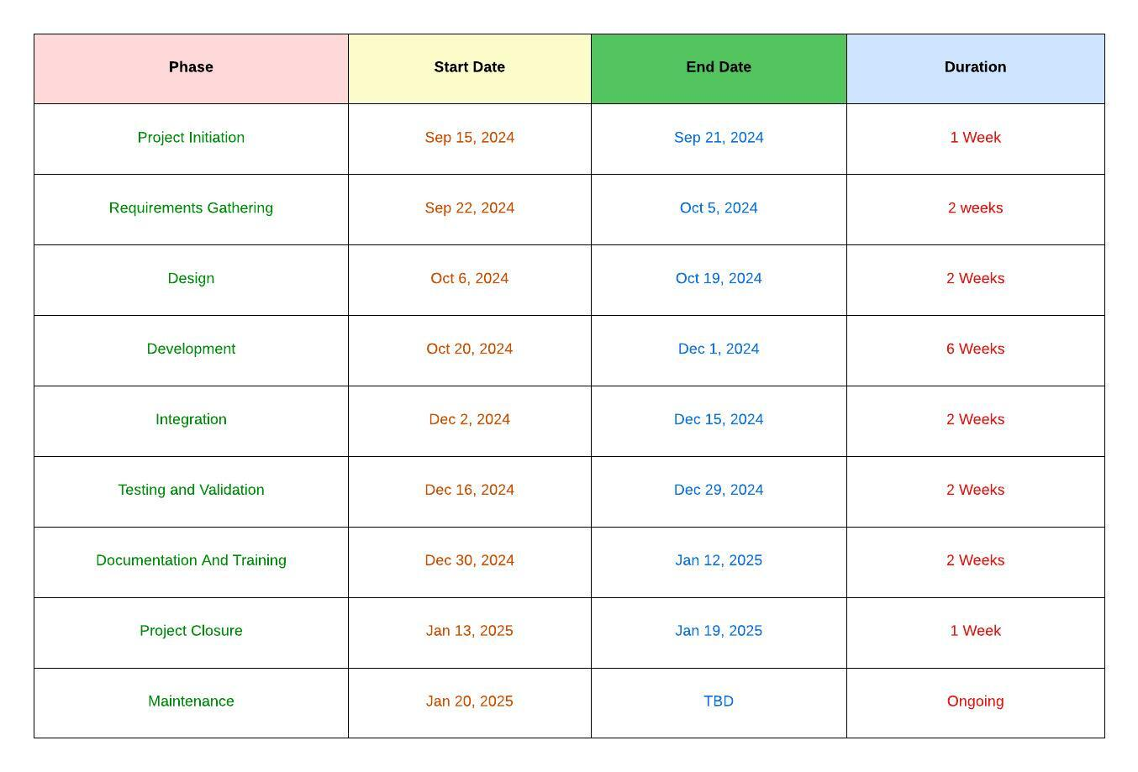

Notes:
- Change Requests: Any changes in scope or timelines will follow a formal change management process.
- Goal Alignment: Regular reviews will ensure alignment with project objectives and stakeholder expectations.

References
- Project Management Institute. (2021). A Guide to the Project Management Body of Knowledge (PMBOK Guide). Project Management Institute.
- Kerzner, H. (2019). Project Management: A Systems Approach to Planning, Scheduling, and Controlling. Wiley.
- Fisher, R., & Ury, W. (1981). Getting to Yes: Negotiating Agreement Without Giving In. Penguin Books.

